Parts Exchange Overview

## OVERVIEW of business process

Parts Exchange otherwise known as PEX items are components that a customer agrees to buy from us multiple times at a reduced cost. We recondition the item each time before reselling it. We charge a one off fee and charge for parts and labour needed for the rebuild. The Component Rebuild Centre below was purpose built for this process.

<http://goughgroup.co.nz/images/PDFs/OctNov_GoughsQM.pdf>

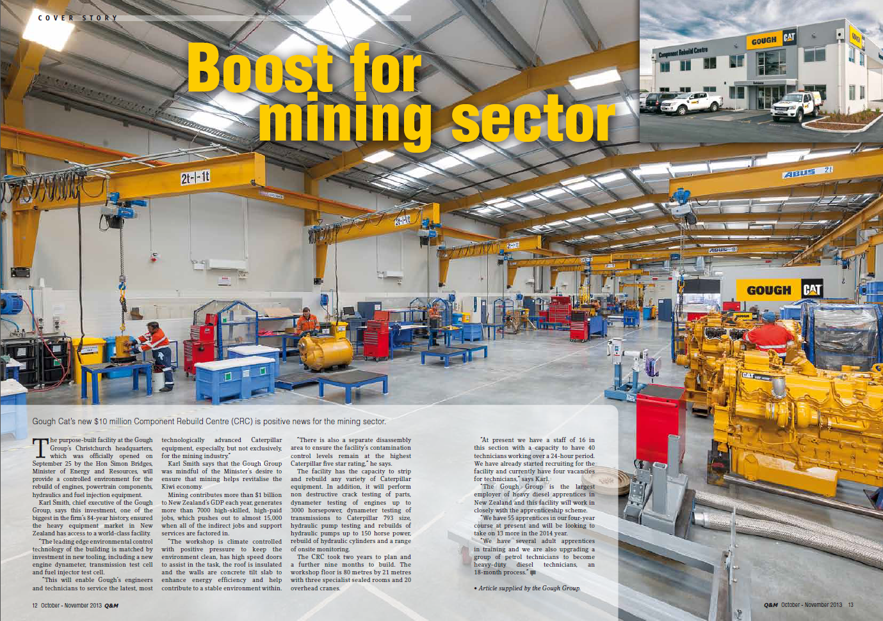

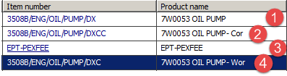

1. PEX Item (ends in DX)

2. PEX Core charge (ends in DXCC)

3. PEX fee

4. PEX worn core (ends in DXC)

***Please always sell the item to the customer on a service segment sales order. There is no need to do this process on a direct sale unless the items are being sold outright.***

1. Segment 01: Sell the PEX item and PEX core charge to a service call, add a PEX FEE and produce delivery note. PEX item goes to customer.
2. Segment 01: PEX item returns from customer. Issue the PEX worn core credit.
3. Segment 02: PEX item is rebuilt. Charge for parts and labour
4. Segment 03: Put the PEX item back in stock. Credit an internal account to put the PEX item on stock, and charge the same account to remove the PEX worn core from stock.

## Create a service call with three segments

Create a service call and add three segments. The first two segments should be to the customer, and the third to internal account 5000251 00-EPT Exchange Worn Core Returns.

See more on how to do this here:

*SER_1.2(SOP)Create a Service Call*

Go to Sales and marketing > Common > Sales orders > All sales orders and find the sales orders. Make a note of these with their service segment IDs.

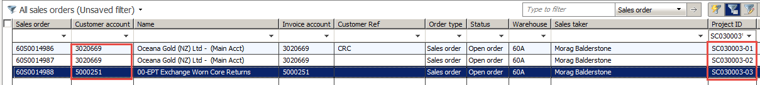

# Segment 1

## Sale of PEX item and exchange fee

*Go to the sales order relating to segment 01. This will be for the sale and worn core credit.*

*NOTE! The sale must be done first and posted, and the worn core credit must* ***not*** *be done until the PEX item has been returned by the customer so that we can track what is with the customer, and what has been physically returned.*

### Backorder transfer

If the PEX item is not in your warehouse, *Follow this SOP if a backorder transfer is needed*: PRT_3.4(SOP)Source Parts through Backorder*

*If it’s coming via a transfer order, the picking journal will not be able to be processed until the serial number is added. If you cannot see the serial number field add it by clicking on **Dimensions display** and ticking the **Serial number** tickbox.

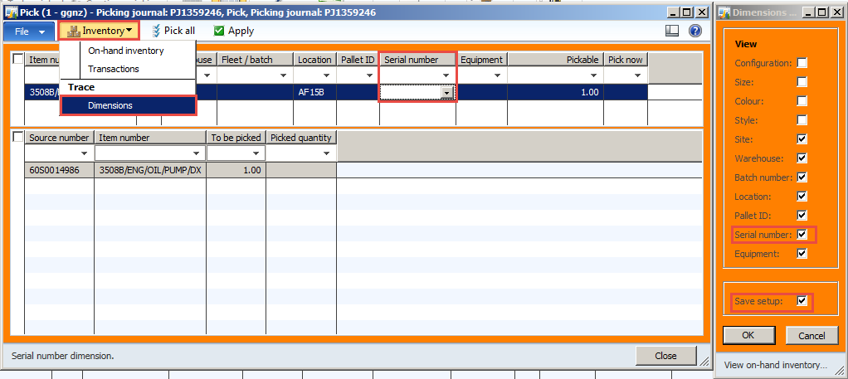

If serial number is not known or is not applicable, add ‘N/A’ to the serial number field. Then process the picking journal as usual. A packing slip will be produced just for the PEX item and PEX core charge. You’ll need to remember to charge the PEX fee separately.

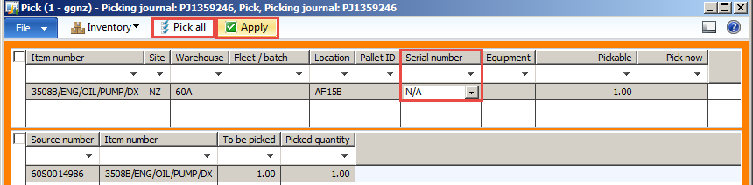

### Picking from your stock

If the PEX item is already in your warehouse, you could create a picking journal and use the steps above **however,** then the PEX fee won’t appear on the same packing slip as the PEX item which may result in it being missed, so instead go to Sales order lines > Update line > Pick.

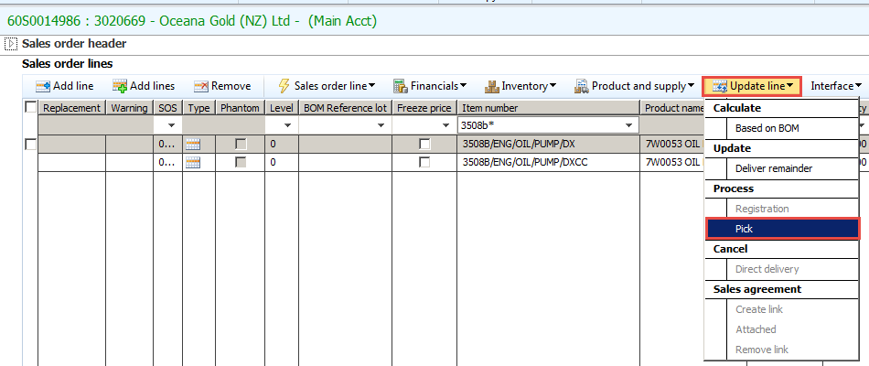

If you cannot see the serial number field add it by clicking on **Dimensions display** and ticking the **Serial number** tickbox. If serial number is not known or is not applicable, add ‘N/A’ to the serial number field.

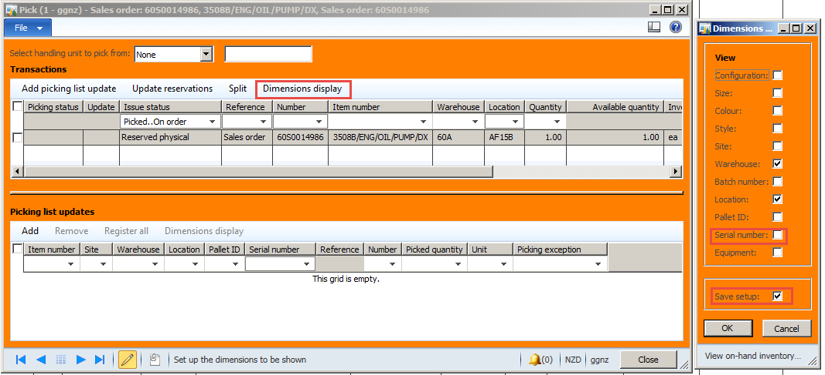

After populating Serial number column, click **Add picking list update**, type in serial number then click **Register all**. Picking status will change to Picked.

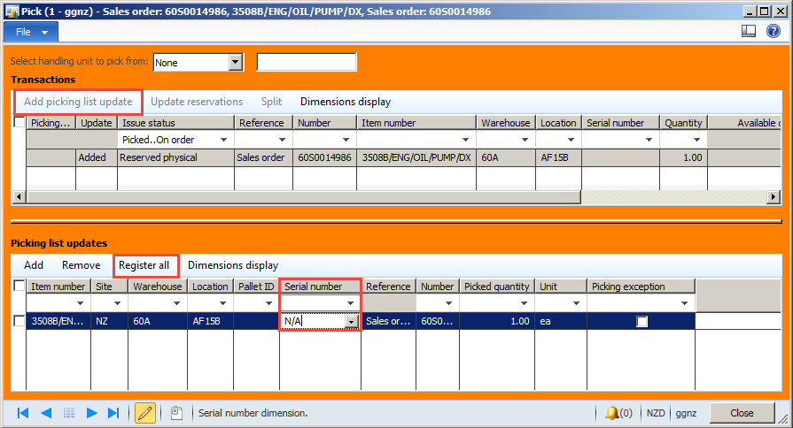

*NOTE! If you do not add a serial number, the following Infolog will appear. Close the Infolog and follow steps above to populate the serial number.*

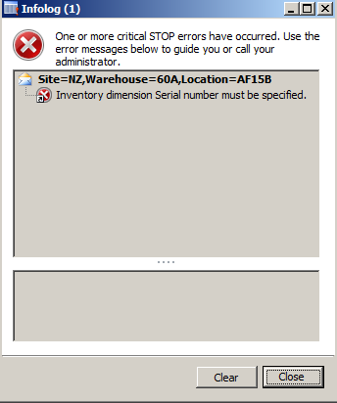

Next add the service item EPT-PEXFEE and type in the appropriate fee into the Unit price field. This is the agreed amount to be charged for this particular PEX item for this particular customer. In some cases if the component has had enough ‘turns’ (been bought by the customer the required number of times) there may be no fee to charge. For any queries on fees please contact the National Parts Manager.

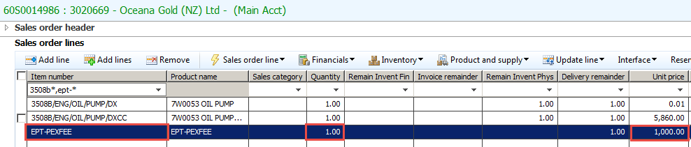

When creating the packing slip for the PEX item and fee, go to Pick and pack > Delivery note and select All in the drop down to ensure you will pick up the service item. If this drop down is set to picked, your service item will not be selected. Go to the Lines tab and remove any items you do not want to post right away by ticking the row and clicking delete, leaving your 3 lines for PEX item, PEX core charge and PEX fee, then click ok.

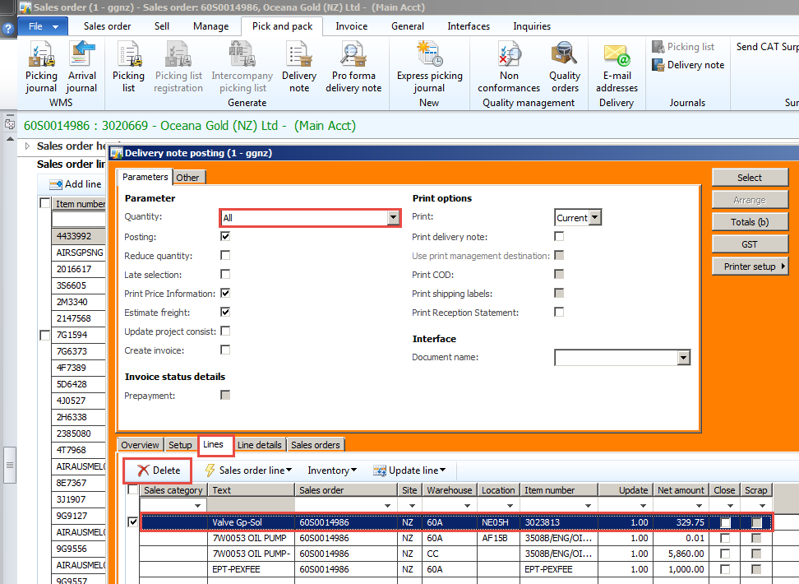

The packing slip will be produced.

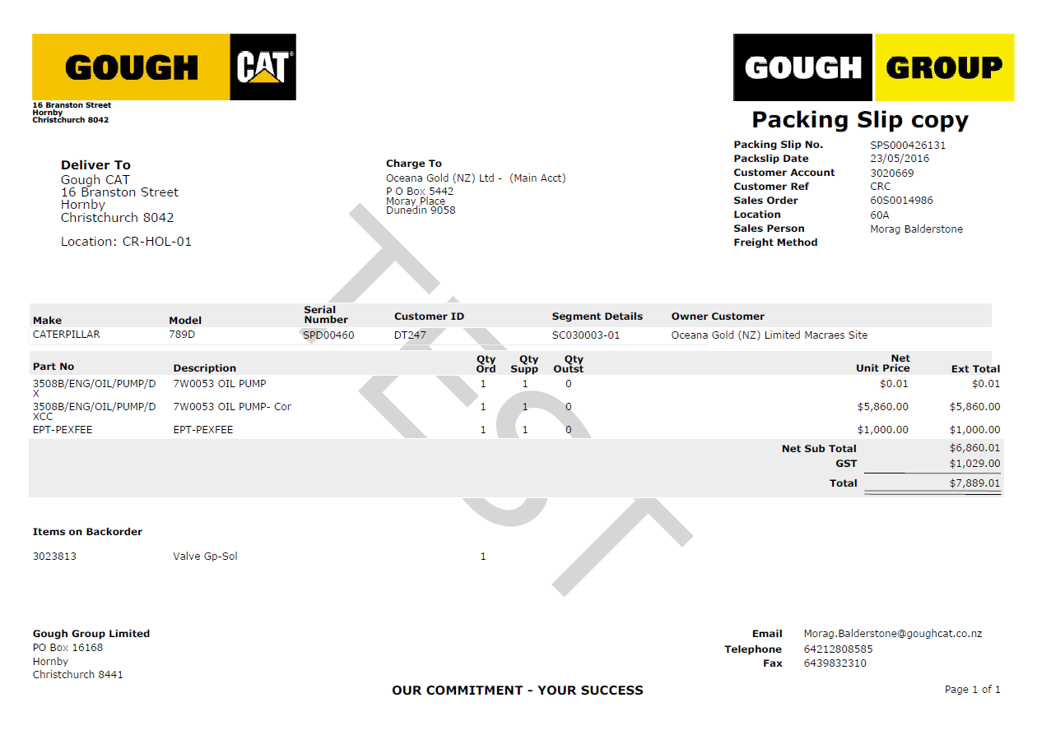

*Once the packing slip is produced, give the PEX item to the customer.*

## Worn core credit

*When the customer returns the PEX item Use the normal* ***full core return*** *process to do the PEX worn core credit. This will bring the PEX item with a C on the end as below into the lines. Create a packing slip for this to post it to the segment.*

PRT_9.1(SOP)Process a Core Return

Your segment sales order should look like this: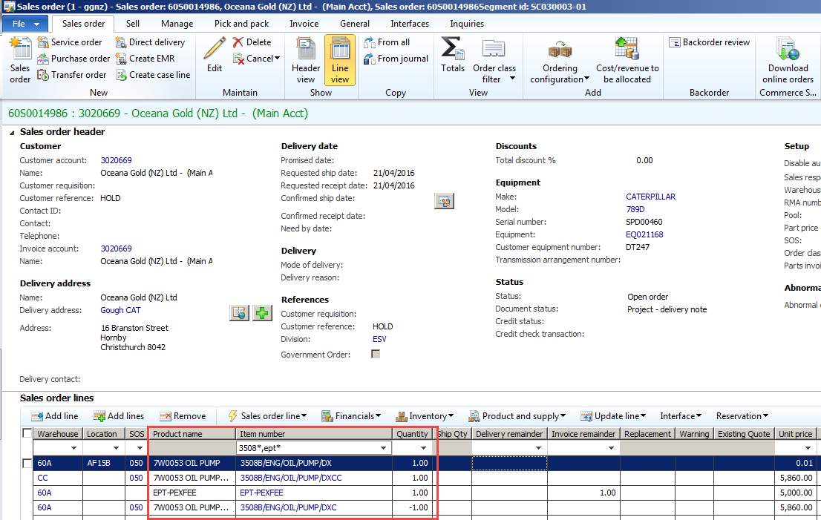

# Segment 2

## Rebuilding the PEX item

On this segment please add any labour, parts, items, misc charges needed to rebuild the exchange item.

Labour

Parts

OWM

Etc.

Follow the instructions found on the intranet under **Sales Order (Parts),** **Service** etc as needed to do this.

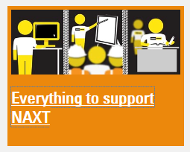

# Segment 3

## Putting PEX item back into stock and taking the worn core out of stock using internal account 5000251 - ‎

*This process should only be done if the worn core has been rebuilt and is ready to be resold.*

*This segment should have the same PEX item, and PEX worn core that were sold on segment 1. The PEX fee should not be added to segment 3.*

*NOTE the PEX item (and PEX core charge) should be for quantity -1 and the PEX worn core should be for quantity 1:*

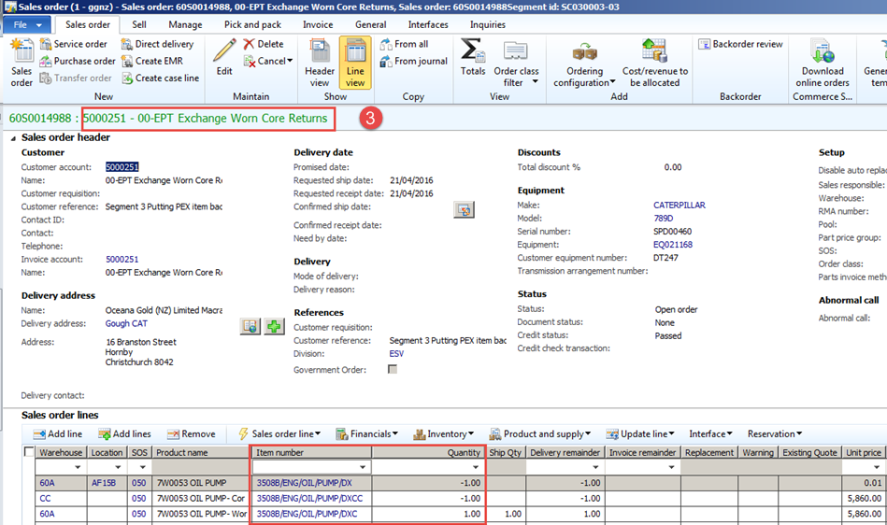

Copy the PEX item from segment one or type it in to segment 3. Change the quantity on the PEX item to a negative. Go to Sales order lines > Update line > Registration

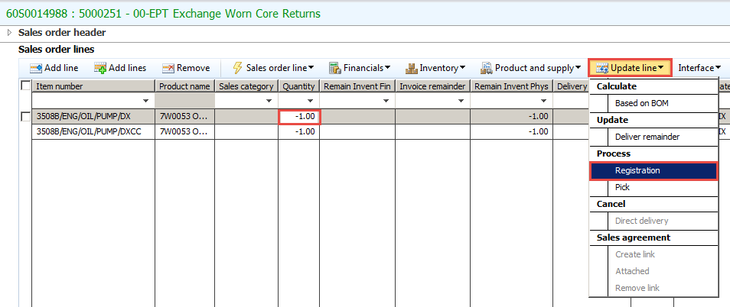

Click Auto-create, Post all. Receipt status will change to **Registered**. Close. (No serial number is needed)

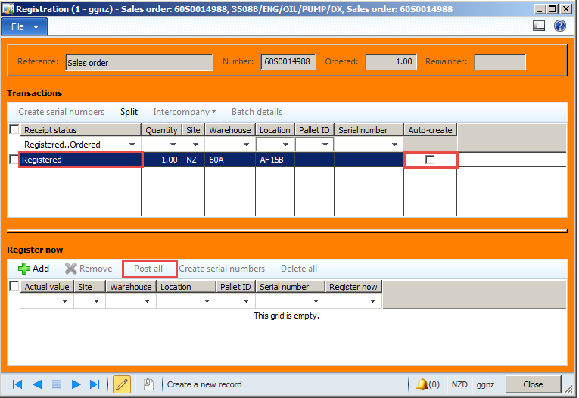

Add the worn core item with a positive quantity.

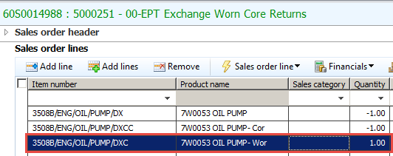

Pick the worn core out of stock by going to Sales order lines > Update line > Pick

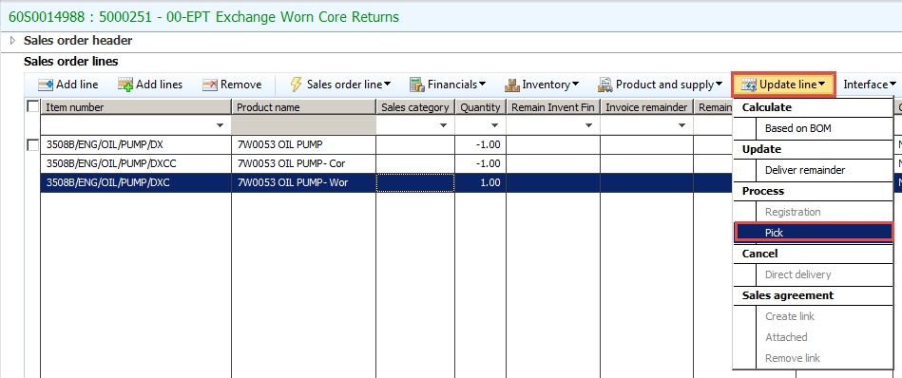

When picking the worn core, add serial number using Dimensions display if necessary, press Add picking list update > Add serial number > Register all. If Serial number is not known, type N/A.

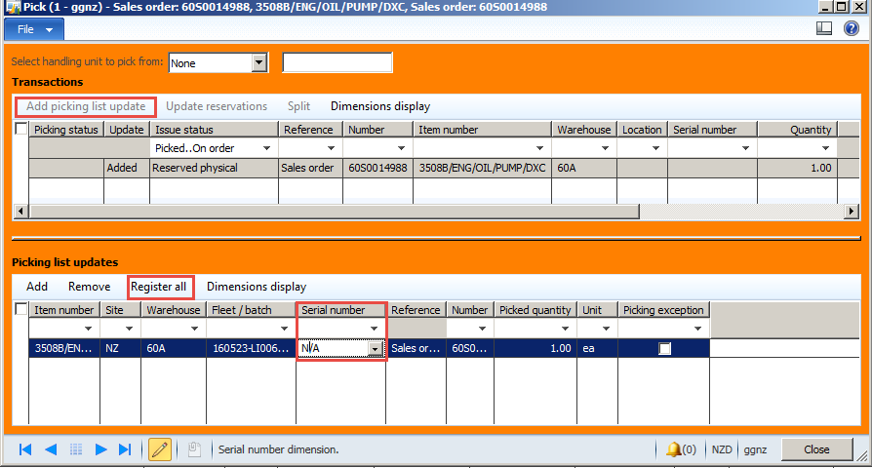

Picking status will change to Picked.

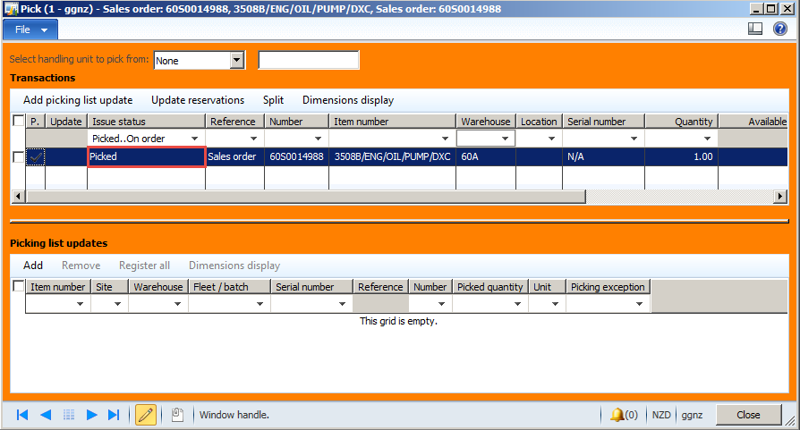

Go to Pick and pack > Delivery note > Lines.

Check the drop down selected is ‘All’ and the lines you want to post are visible. If extra lines appear that you do not want to post, remove them by selecting them and clicking the delete, then click ok.

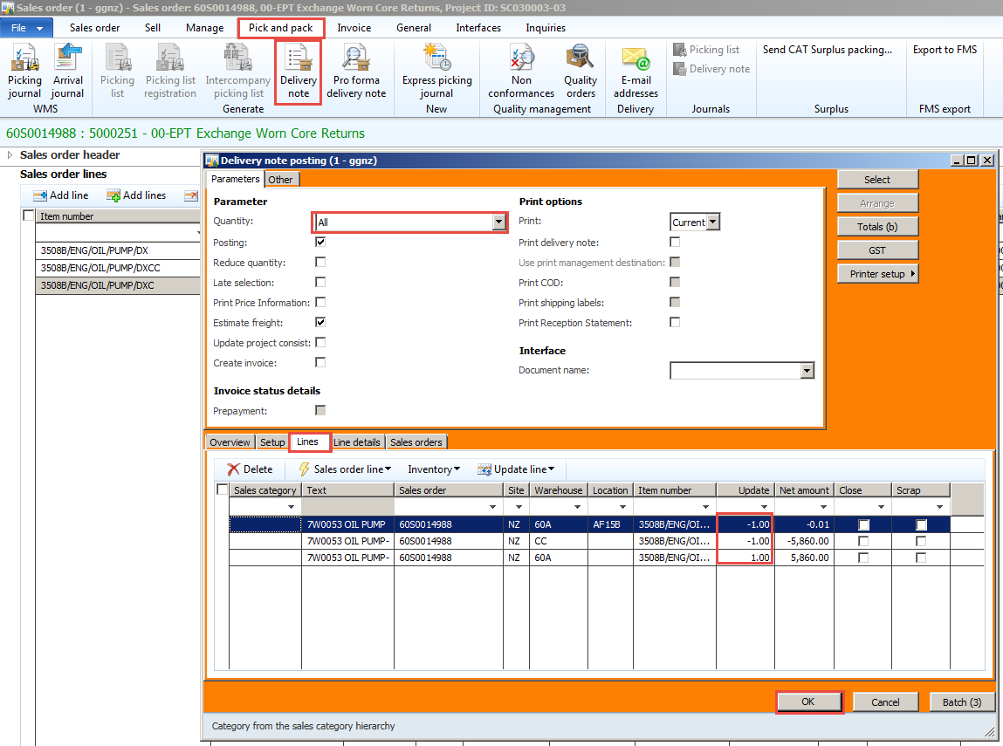

Items are posted.

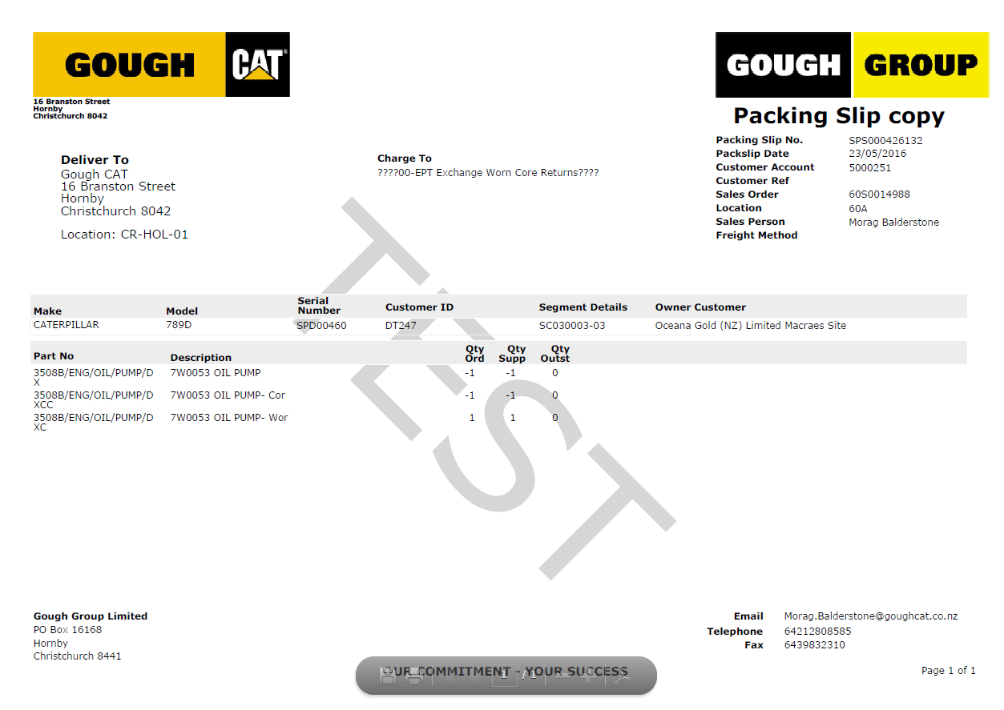

Item is now on hand and is ready to be sold again:

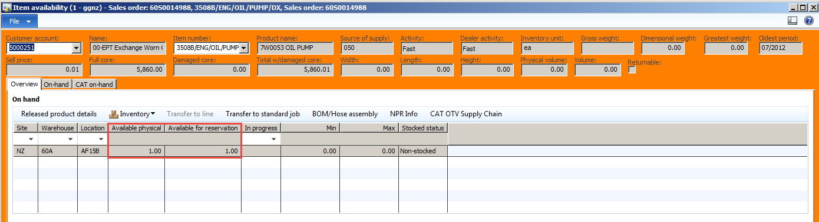

Worn Core is not on hand anymore.

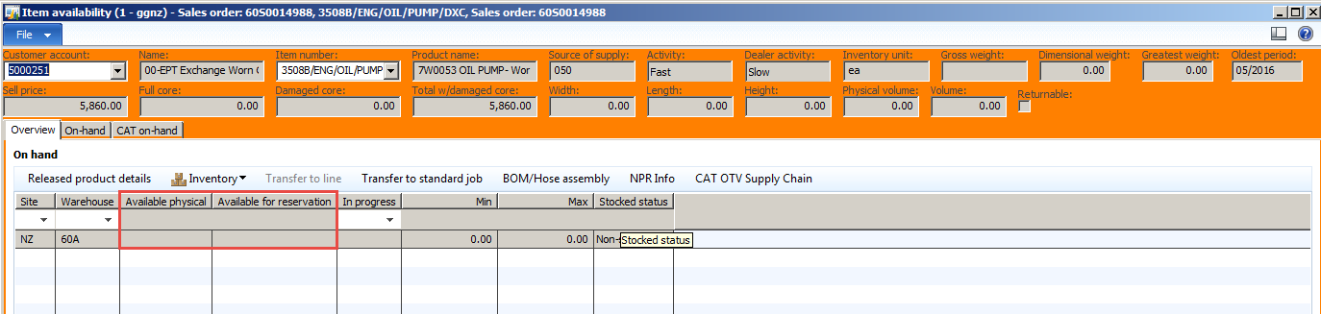

# Tracking PEX items sold to customer, not yet returned

Go to inventory and warehouse management > Core history

Filter by Item like this: *DX*

Filter by Outstanding quantity like this: >0

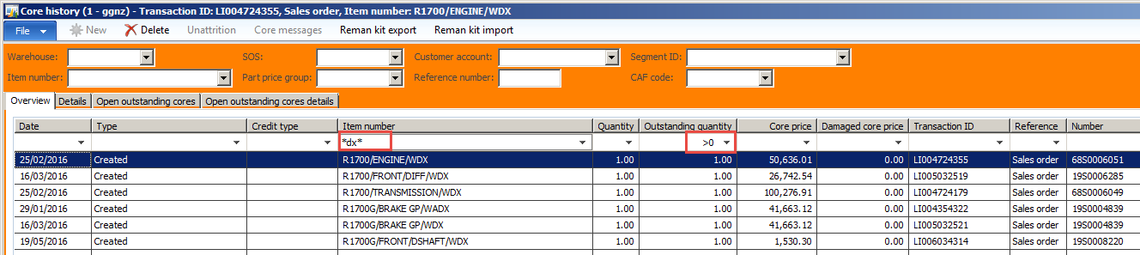

All of these items are currently with customers.